Name : Yash Raj
Roll Number : 24k-0737
Task#1:
Code:
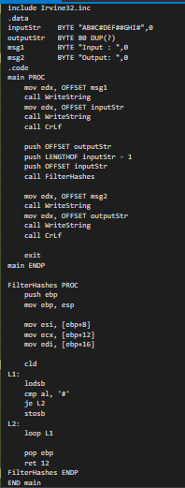
Output:
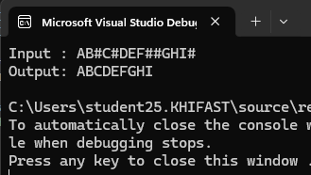
Task#2:
Code:
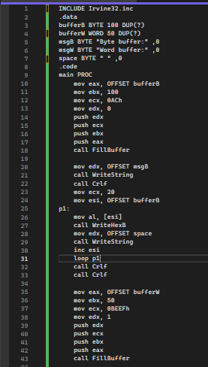
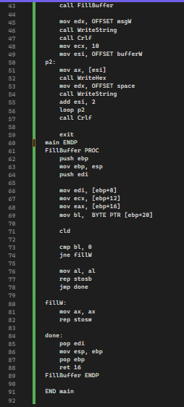

Output:
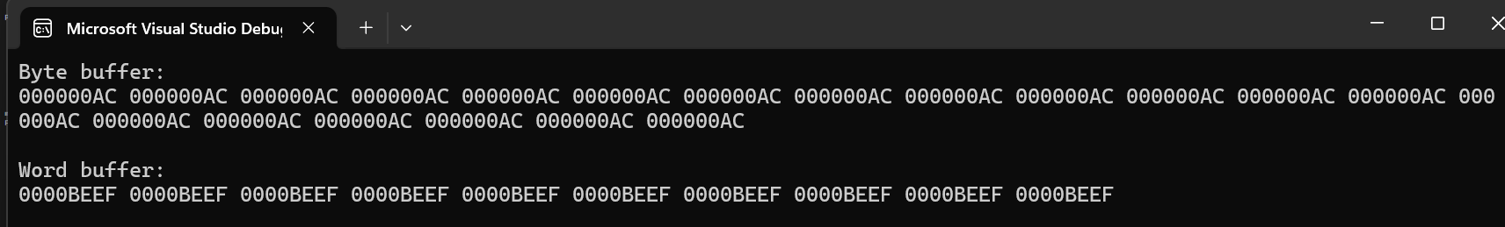
Task#3:
Code:
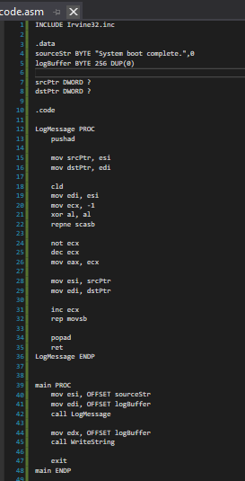
Output:
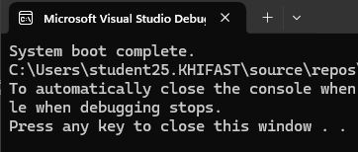
Task#4:
Code:
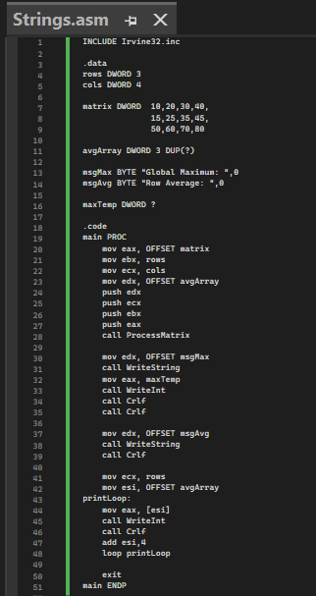
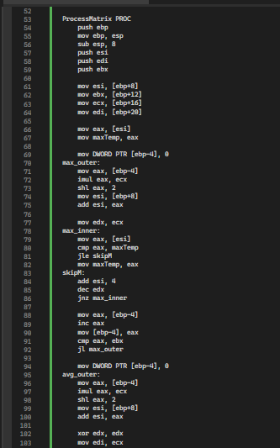
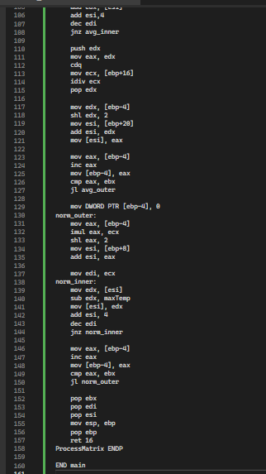

Output:
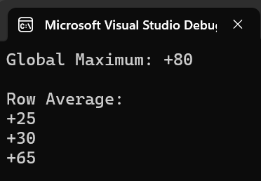

Task#5:
Code:
INCLUDE Irvine32.inc

.data
arr DWORD 40,10,50,20,30
arrCount DWORD 5
space BYTE " ",0

.code
main PROC
mov eax, OFFSET arr
mov ebx, arrCount
mov ecx, 1
push ecx
push ebx
push eax
call BubbleSort

exit
main ENDP

BubbleSort PROC
push ebp
mov ebp, esp
sub esp, 4
push esi
push edi
push ebx

mov esi, [ebp+8]
mov ebx, [ebp+12]
mov edi, [ebp+16]

start_outer:
mov DWORD PTR [ebp-4], 0
mov ecx, ebx
dec ecx
mov esi, [ebp+8]

inner_loop:
mov eax, [esi]
mov edx, [esi+4]
cmp eax, edx
jle skip_swap

mov [esi], edx
mov [esi+4], eax
mov DWORD PTR [ebp-4], 1

skip_swap:
add esi, 4
dec ecx
jnz inner_loop

mov eax, [ebp-4]
cmp eax, 1
je start_outer

cmp edi, 1
jne done_print

mov ecx, ebx
mov esi, [ebp+8]
print_loop:
mov eax, [esi]
call WriteInt
call Crlf
add esi, 4
loop print_loop

done_print:
pop ebx
pop edi
pop esi
mov esp, ebp
pop ebp
ret 12
BubbleSort ENDP

Output:
